DONALD COUTTS

CIT185753 Kitman Yiu

Testing Metrics

Application Testing & Metrics

目錄

Introduction 2

Background 2

Metrics Life Cycle 3

SOFTWARE METRICS 4

SUBSET 4

Test PROCESS Metrics 4

Test Product Metrics 5

Product Quality Measures 5

TYPE OF METRICS 8

Recommendations 8

Importance of Metrics 8

Examples 10

Angry Bird 10

Description 10

Applying Testing Metrics 11

RATM 11

Applying Testing Metrics 11

GTA 5 12

Introduction 13

Applying Testing Metrics 13

Conclusion 14

REFERENCE 14

# Introduction

There is variety of literature pertaining to programming and gaming. Additionally, there is also a lot of information about software testing metrics principles, however this information has never before been applied in a games environment. As such, this essay will examine “testing metrics principles” as they are applied in a games environment. Firstly, the benefits of applying testing metrics will be considered. Next, the elements in testing metrics we be analysed to determine the benefits of each of these. Lastly, examples of both good and bad metrics we be presented and a discussion of how these can applied to small and large game companies will follow.

# Background

In the Programming discipline there are well established testing metrics: software testing metrics are the “Standards of measurement”.**(Important Software Test Metrics and Measurements – Explained with Examples and Graphs — Software Testing Help. 2015).** The goal of Testing Metrics is too enable Test Leaders to measure software quality, so they can deliver the best product to the customer. Within Software testing metrics there are three categories to be investigated: Test Process Metrics, Test Product Metrics and Test Project Metrics

It must be clearly noted that software Metrics and Software Testing Metrics are not terms which can be used interchangeably. Rather, Software Test Metrics are a specific category of the much broader concept of Software Metrics. Furthermore, both Direct and Indirect Metrics are independent of Testing Metrics **(Ming-Chang Lee, To Chang)**

# Metrics Life Cycle

The main goal of the testing Life Cycle, is to be able to give us the following ideas

* Who will collect metrics data?
* When will the metrics data be collect?
* How the metrics data will be collected.

Notice: All these will be written in a test plan document

# SOFTWARE METRICS

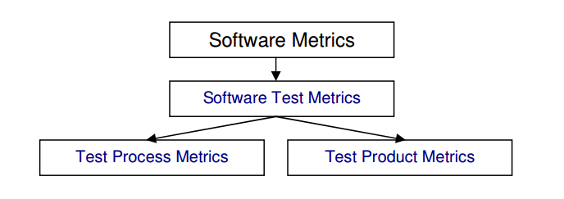

A metric is a quantifiable measurement of software product, process, or project that is directly observed, calculated, or predicted. **(Robert T. Futrell, Donald F. Shafer, Linda Shafer, 2011. Quality Software Project Management).** Metrics (or indicators) are computed from measures. Metrics facilitate the quantification of some particular characteristic. Metrics are measurements of different aspects of an endeavor that help us determine whether or not we are progressing toward the goal of that endeavor. **(Sheikh Umar Farooq. SOFTWARE MEASUREMENTS AND METRICS: ROLE IN EFFECTIVE SOFTWARE TESTING)** Metrics are usually specialized by the subject area, in which case they are valid only within a certain domain and cannot be directly benchmarked or interpreted outside it: "Essentially, software metrics deals with the measurement of the software product and the process by which it is developed. They are quantifiable indices used to compare software products, processes, or projects or to predict their outcomes” Software Metrics should be well defined before they are utilized; Table 1 defines the elements that must be defined properly. With Software testing metrics, we can:

* Monitor requirements
* Predict development resources
* Track development progress
* Understand maintenance costs

# SUBSET

## Test PROCESS Metrics

The goal of Process metrics is to determine how much time and money it took during the development of the game. The following examples are some things which we can test. The following examples are also some aspects it took during the development stages of a standard game.

* Test Coverage = Number of units (KLOC/FP) tested / total size of the system. (LOC represents Lines of Code)
* Number of tests per unit size = Number of test cases per KLOC/FP (LOC represents Lines of Code).
* Acceptance criteria tested = Acceptance criteria tested / total acceptance criteria
* Defects per size = Defects detected / system size
* Test cost (in %) = Cost of testing / total cost *100
* Cost to locate defect = Cost of testing / the number of defects located
* Achieving Budget = Actual cost of testing / Budgeted cost of testing
* Defects detected in testing = Defects detected in testing / total system defects
* Defects detected in production = Defects detected in production/system size
* Quality of Testing = No of defects found during Testing/(No of defects found during testing + No of acceptance defects found after delivery) *100
* Effectiveness of testing to business = Loss due to problems / total resources processed by the system.
* System complaints = Number of third party complaints / number of transactions processed
* Scale of Ten = Assessment of testing by giving rating in scale of 1 to 10
* Source Code Analysis = Number of source code statements changed / total number of tests.
* Effort Productivity = Test Planning Productivity = No of Test cases designed / Actual Effort for Design and Documentation
* Test Execution Productivity = No of Test cycles executed / Actual Effort for testing

## Test Product Metrics

The goal of Product metrics is to determine what the quality of the game is. The following examples are some things which we can test.

### Product Quality Measures

The following table is referenced from (Metrics Used In Testing)

|  |  |
| --- | --- |
| **Test Metric** | **Description** |
|  | |
| **Customer satisfaction index**  This index is surveyed before product delivery and after product delivery  (and on-going on a periodic basis, using standard questionnaires).The following are analyzed: | |
| Number of system enhancement requests per year | For a game this can be just one year |
| Number of maintenance fix requests per year | For a game this can be just one year |
| User friendliness: call volume to customer service hotline , forums , online chat | In game environments this not only includes hotlines, it can also include forums or online chats |
| User friendliness: training time per new user | This can change depending on many players and how players are able to play the game without asking for help |
| Number of product recalls or fix releases (software vendors) |  |
| **Delivered defect quantities** | |
| They are normalized per function point (or per LOC) at product delivery (first 3 months or first year of operation) or Ongoing (per year of operation) by level of severity, by category or cause, e.g.:  requirements defect, design defect, code defect, documentation/on-line help defect, defect introduced by  fixes, etc. | |
| **Responsiveness (turnaround time) to users** | |
| Turnaround time for defect fixes, by level of severity | The level of severity can be defined by the company |
| Time for minor vs. major enhancements; actual vs. planned elapsed time | This metrics will be used when trying to improve the planning process of the game |
| **Product volatility** | |
| Ratio of maintenance fixes (to repair the system & bring it into compliance with specifications), vs. enhancement requests (requests by users to enhance or change functionality) | This maintenance rate should be higher than enhancement requests. |
| **Defect ratios** | |
| Defects found after product delivery per function point. | How many bugs have been found in the game after released |
| Defects found after product delivery per LOC |  |
| **Defect removal efficiency** | |
| Number of post-release defects categorized by level of severity | Bug severity, categorized by level of severity; this can be found by clients in field operation |
| Ratio of defects found internally prior to release (via inspections and testing), as a percentage of all defects | How many bugs have been found before release? |
| All defects include defects found internally plus externally (by customers) in the first year after product delivery | Usually a big game will stop releasing updates after one year |
| **Test coverage** | |
| The ratio of the number of detected faults to the number of predicted faults. |  |
| **Cost of defects** | |
| Business losses per defect that occur during operation | These are related to business goals |
| Business losses per defect that occurs during operation | These are related to business goals |
| Business interruption costs; costs of work-arounds | These are related to business goals |
| Lost sales and lost goodwill | These are related to business goals |
| Litigation costs resulting from defects | These are related to business goals |
| Annual maintenance cost (per function point) | This includes a wide range of cost: For example computers in the company that need to be repaired |
| Annual operating cost (per function point) | This can include bills |
| Measurable damage to your boss's career | This is related to business goals |
| **Costs of quality activities** | |
| Costs of reviews, inspections and preventive measures | These are related to business goals |
| Costs of test planning and preparation | These are related to business goals |
| Costs of test execution, defect tracking, version and change control |  |
| Costs of diagnostics, debugging and fixing |  |
| Costs of tools and tool support | The tools made for the game or the game engine that is used to develop the game such as Maya, Visual Studio 2012. |
| Costs of testing & QA education associated with the product | Allow the QA people to be updated |
| Costs of monitoring and oversight by the QA organization | This needs to be included if separate from the development and test organizations |
| **Re-work** | |
| Re-work effort | hours, as a percentage of the original coding hours |
| Re-work effort | hours, as a percentage of the original coding hours |
| Re-worked LOC | source lines of code, as a percentage of the total delivered LOC |
| Re-worked software components | this is a percentage of the total delivered components |
| **Reliability** | |
| Availability | percentage of time a system is available, versus the time the system is needed to be available |
| · Mean time between failures (MTBF). | How often does it take the game to fail; displayed as a percentage. |
| Man time to repair (MTTR) | How often there is a game failure; displayed as a percentage. |
| Reliability ratio (MTBF / MTTR) | The ratio of MTBF and MTTR. The MTBF should be higher |
| Number of production re-runs as a ratio of production runs |  |

# TYPE OF METRICS

The following figure shows different software testing metrics.

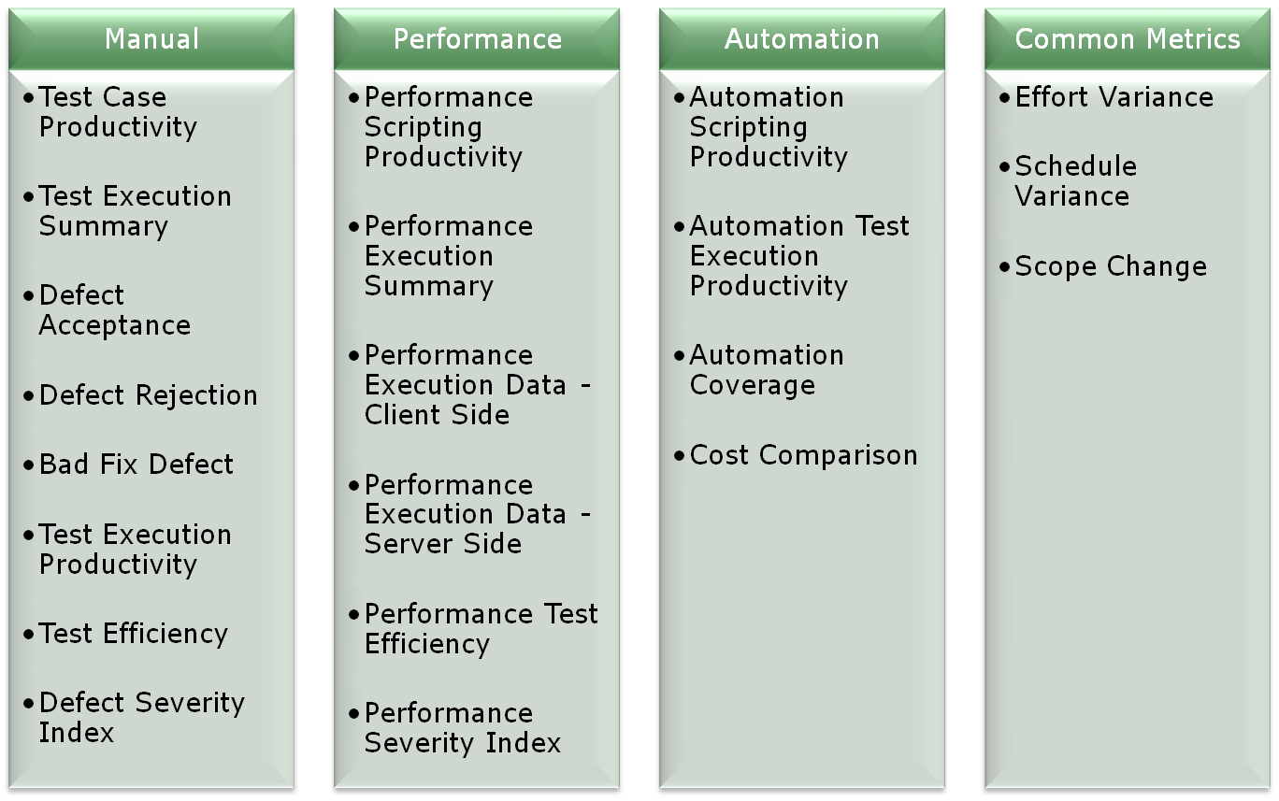

# Recommendations

## Importance of Metrics

Metrics are used to improve the quality and productivity of products and services thus achieving Customer Satisfaction. As such, Metrics help organizations to obtain the information they need to continue to improve their processes, products and services and achieve the desired Goal as: illustrated by **(A Brief Overview Of Software Testing Metrics - ResearchGate. 2015.)**

* "You cannot control what you cannot measure" **(Tom DeMarco)**
* Easy for management to digest one number and drill down, if required.
* Different Metric(s) trends act as a monitor to ensure the project stays on time and on budget.
* Metrics provides improvement for current processes.
* Metrics for which one can collect accurate and complete data must be used.
* Metrics must be easy to explain and evaluate.

|  |  |
| --- | --- |
| **Test Metric** | **Description** |
|  | |
| **Manual Testing Metrics** | |
| Test Case Productivity | Provides the information for the number of step(s) written per hour. |
| Test Execution Summary | Provides statisical view of execution for the release along with the status and reason. |
| Defect Acceptance | Indicates the stability and reliability of the application. |
| Defect Rejection | Provides the percentage of invalid defects. |
| Bad Fix Defect | Indicates the effectiveness of the defect-resolution process |
| Test Execution Productivity | Provides detail of the test case executed per day. |
| Test Efficiency | Indicates the testing capability of the tester in identifying the defect. |
| Defect Severity Index | Provides indications about the quality of the product under test which are not omitted at the time of release. |
| **Performance Testing Metrics** | |
| Performance Scripting Productivity | Provides scripting productivity for performance test flow. |
| Performance Execution Summary | Provides classification with respect to number of tests conducted along with status (Pass/Fail), for various types of performance testing. |
| Performance Execution Data - Client Side | Gives detailed information of Client side data for execution |
| Performance Execution Data - Server Side | Gives detailed information of Server side data for execution |
| Performance Test Efficiency | Indicates the quality of the Performance team in meeting the performance requirement(s). |
| Performance Severity Index | Indicates quality of product under test with respect to performance criteria. |
| **Common metrics for all types of testing** | |
| Effort Variance | Indicates effort stability |
| Schedule Variance | Indicates schedule stability |
| Scope Change | Indicates requirement stability |

# Examples

Metrics to be used is determined by the following factors:

* Team size
* What is the desired outcome?
* Time Frame
* Money

## angry bird

The following scenario applies to the small games environment, specifically Angry Bird.



### Description

Angry Birds is a [puzzle](http://en.wikipedia.org/wiki/Puzzle_video_game) [video game](http://en.wikipedia.org/wiki/Video_game) developed by [Finnish](http://en.wikipedia.org/wiki/Finns) [computer game developer](http://en.wikipedia.org/wiki/Computer_game_developer) [Rovio Entertainment](http://en.wikipedia.org/wiki/Rovio_Entertainment) whom also started the [Angry Birds](http://en.wikipedia.org/wiki/Angry_Birds) franchise. Inspired primarily by a sketch of stylized wingless birds, the game was first released for [iOS](http://en.wikipedia.org/wiki/IOS) in December 2009. Since that time, over 12 million copies of the game have been purchased from the iOS [App Store](http://en.wikipedia.org/wiki/App_Store_(iOS)), which has prompted the company to design versions for other touchscreen-based [smartphones](http://en.wikipedia.org/wiki/Smartphone), most notably those using the [Android](http://en.wikipedia.org/wiki/Android_(operating_system)), [Symbian](http://en.wikipedia.org/wiki/Symbian), [Windows Phone](http://en.wikipedia.org/wiki/Windows_Phone) and [BlackBerry 10](http://en.wikipedia.org/wiki/BlackBerry_10) operating systems. The series has since expanded to include titles for dedicated [video game consoles](http://en.wikipedia.org/wiki/Video_game_console) and for [PCs](http://en.wikipedia.org/wiki/Personal_computer) as well as a vast array of novelty products, a clothing line for children, home furnishings and other products.

In the game, players use a [slingshot](http://en.wikipedia.org/wiki/Slingshot) to launch birds at pigs stationed in or around various structures with the goal of destroying all the pigs on the playing field. As players advance through the game new types of birds become available, some with special abilities that can be activated by the player. Rovio Mobile has supported Angry Birds with numerous free updates that add additional game content, and the company has also released stand-alone holiday and promotional versions of the game.( **June 2013 | Free Offline Games Full Version - Download Game Free Unlimited . 2015)**

### Applying Testing Metrics

Assume of following data

* Team size: 1
* What is the desired outcome? To find out how much fun players have while playing the game
* Time Frame: Not Limited
* Budget :Not Limited

The following metrics can be applied

* Number of bugs which have been reported after release: By knowing this result we can determine if a tester should be hired or if more testing in the next game should be done because bugs can decrease the game experience.
* User friendliness of the game: direct measures to determine how fun the player was having after playing the game.
* The test case pass percentage: this can help us determine if we should stop testing or not

## GTA 5

Apply to large game, GTA



### Introduction

Grand Theft Auto V is an [open world](http://en.wikipedia.org/wiki/Open_world), [action-adventure](http://en.wikipedia.org/wiki/Action-adventure_game) video game developed by [Rockstar North](http://en.wikipedia.org/wiki/Rockstar_North) and published by [Rockstar Games](http://en.wikipedia.org/wiki/Rockstar_Games). It was released on 17 September 2013 for the [PlayStation 3](http://en.wikipedia.org/wiki/PlayStation_3) and [Xbox 360](http://en.wikipedia.org/wiki/Xbox_360). An [enhanced version of the game](http://en.wikipedia.org/wiki/Grand_Theft_Auto_V_(re-release)) was released on 18 November 2014 for the [PlayStation 4](http://en.wikipedia.org/wiki/PlayStation_4) and [Xbox One](http://en.wikipedia.org/wiki/Xbox_One), and 14 April 2015 for [Microsoft Windows](http://en.wikipedia.org/wiki/Microsoft_Windows). The game is the first main entry in the [Grand Theft Auto series](http://en.wikipedia.org/wiki/Grand_Theft_Auto_(series)) since 2008's [Grand Theft Auto IV](http://en.wikipedia.org/wiki/Grand_Theft_Auto_IV). Set within the fictional state of San Andreas (based on [Southern California](http://en.wikipedia.org/wiki/Southern_California)), the [single-player](http://en.wikipedia.org/wiki/Single-player_video_game) story follows three criminals and their efforts to commit heists while under pressure from a government agency. The open world design lets players freely roam San Andreas, which includes open countryside and the fictional city of Los Santos (based on [Los Angeles](http://en.wikipedia.org/wiki/Los_Angeles)).

The game is played from either a [third-person](http://en.wikipedia.org/wiki/Third-person_view) or [first-person view](http://en.wikipedia.org/wiki/First-person_view) and its world is navigated on foot or by vehicle. Players control the three lead protagonists throughout the single-player mode, switching between them both during and outside of missions. The story is centered on the heist sequences, and many of the missions involve shooting and driving gameplay. Players who commit crimes may incite a response from law enforcement agencies, measured by a "wanted" system that governs the aggression of their response. [Grand Theft Auto Online](http://en.wikipedia.org/wiki/Grand_Theft_Auto_Online), the [online multiplayer](http://en.wikipedia.org/wiki/Online_multiplayer) mode, lets up to 30 players explore the open world and engage in [cooperative](http://en.wikipedia.org/wiki/Cooperative_gameplay) or competitive game matches. (**GTA 5 for PC Release Date, Delayed Again)**

### Applying Testing Metrics

Assume the following data

* Team size: 40
* Goal: release a good product (this include finishing the game on time and generating; significantly amount of revenue) and doing revisions of the game to enhance its overall performance.
* Time : No Limited
* Budget :No Limited

First of all we should run life cycles to establish

* Who will collect the data?
* When will the data be collected?
* How will it be collected?

This will vary heavily depending on the company: how often these test should be done can be determined if we apply process metrics as we can apply process metrics to the test people , and by applying different types of testing we can see if the product is on schedule.

We can apply the following metrics

* Number of bugs which have been reported after release: By knowing this result we can determine if a tester should be hired or if more testing in the next game should be done because bugs can decrease the game experience.
* User friendliness of the game: directly measures how much the player is having fun after playing the game.
* The test case pass percentage: this can help us determine if we should stop testing or not
* Number of system enhancement requests per year: To determine if the team members are producing efficiently
* Cost of test planning and preparation

# Conclusion

Testing Metrics have been applied in a games environments, however, this has never accrued in a formal way, or if they have, literature documenting these process has not been made public. After extensive research, it has come to light that Testing Metrics of individual games needed.

Furthermore, to be able to apply testing metrics into game environments more literature documenting must clarify the relationship between Product Quality Measures, Software Metrics and Software Test Metrics, because despite copious research, no clear relationship has been published in the existing literature. Thus, there remains a significant dearth of literature pertaining to these testing measures, particularly as they are applied to a games environments.

# REFERENCE

Amazon.com: Testing Metrics: Measuring Product, Process and Project Quality eBook: Rex Black: Kindle Store. 2015. Amazon.com: Testing Metrics: Measuring Product, Process and Project Quality eBook: Rex Black: Kindle Store. [ONLINE] Available at: <http://www.amazon.com/Testing-Metrics-Measuring-Product-Process-ebook/dp/B008S2A25A/ref=sr_1_1?s=digital-text&ie=UTF8&qid=1430998135&sr=1-1&keywords=Testing+Metrics>. [Accessed 11 May 2015].

Software Test Metrics - Official Website of Edista Testing Institute. 2015.Software Test Metrics - Official Website of Edista Testing Institute. [ONLINE] Available at: <http://www.edistatesting.com/training/test-project-management/software-test-metrics/>. [Accessed 11 May 2015].

A Brief Overview Of Software Testing Metrics - ResearchGate. 2015. A Brief Overview Of Software Testing Metrics - ResearchGate. [ONLINE] Available at:<http://www.researchgate.net/publication/50247283_A_Brief_Overview_Of_Software_Testing_Metrics>. [Accessed 11 May 2015].

Grand Theft Auto V - Wikipedia, the free encyclopedia. 2015. Grand Theft Auto V - Wikipedia, the free encyclopedia. [ONLINE] Available at:<http://en.wikipedia.org/wiki/Grand_Theft_Auto_V>. [Accessed 11 May 2015].

Angry Birds (video game) - Wikipedia, the free encyclopedia. 2015. Angry Birds (video game) - Wikipedia, the free encyclopedia. [ONLINE] Available at:<http://en.wikipedia.org/wiki/Angry_Birds_%28video_game%29>. [Accessed 11 May 2015].

Important Software Test Metrics and Measurements – Explained with Examples and Graphs — Software Testing Help. 2015. Important Software Test Metrics and Measurements – Explained with Examples and Graphs — Software Testing Help. [ONLINE] Available at:<http://www.softwaretestinghelp.com/software-test-metrics-and-measurements/>. [Accessed 11 May 2015].

Software Measurement and Software Metrics in Software Quality. Ming-Chang Lee, To Chang, 2015. . [ONLINE] Available at: <http://www.researchgate.net/profile/Ming-Chang_Lee2/publication/260480820_Software_measurement_and_software_metrics_in_software_quality/links/0c960531691064e957000000.pdf>. [Accessed 13 May 2015].

 Robert T. Futrell, Donald F. Shafer, Linda Shafer, 2011. Quality Software Project Management. Quality Software Project Management, [Online]., 729. Available at: <https://books.google.com.au/books?id=8GqC7xHTwGsC&printsec=frontcover#v=onepage&q=A%20metric%20is%20a%20quantifiable%20measurement%20of%20software%20product%2C%20process%2C%20or%20project%20that%20is%20directly%20observed%2C%20calculated%2C%20or%20predicted&f=false>[Accessed 14 May 2015].

Sheikh Umar Farooq. SOFTWARE MEASUREMENTS AND METRICS: ROLE IN EFFECTIVE SOFTWARE TESTING, [Online], 729. Available at: http://www.researchgate.net/profile/Sheikh_Umar_Farooq/publication/50392202_SOFTWARE_MEASUREMENTS_AND_METRICS_ROLE_IN_EFFECTIVE_SOFTWARE_TESTING/links/53ee42d00cf26b9b7dc65bb7.pdf [Accessed 14 May 2015].

Metrics Used In Testing, [Online], 1. Available at: http://elearn.cit.edu.au/mod/equella/view.php?id=1024075 [Accessed 14 May 2015].

June 2013 | Free Offline Games Full Version - Download Game Free Unlimited . 2015. June 2013 | Free Offline Games Full Version - Download Game Free Unlimited. [ONLINE] Available at: <http://free-offline-games.blogspot.com.au/2013_06_01_archive.html>. [Accessed 13 May 2015].

GTA 5 for PC Release Date, Delayed Again : News : Celebeat. 2015. GTA 5 for PC Release Date, Delayed Again : News : Celebeat. [ONLINE] Available at: <http://www.celebeat.com/articles/18468/20150213/gta-5-pc-release-date-delayed-again.htm>. [Accessed 13 May 2015].

A Brief Overview Of Software Testing Metrics - ResearchGate. 2015. A Brief Overview Of Software Testing Metrics - ResearchGate. [ONLINE] Available at:<http://www.researchgate.net/publication/50247283_A_Brief_Overview_Of_Software_Testing_Metrics>. [Accessed 18 May 2015].